**Unified Data Standards**

Unified Data Standards for the Internet of Things (IoT) refer to a common set of protocols, formats, and structures for organizing and transmitting data generated by IoT devices. These standards play a crucial role in ensuring interoperability, scalability, and efficient data exchange among diverse IoT devices, platforms, and applications. Here are some key aspects and benefits of unified data standards for IoT:

**Interoperability:** Unified data standards enable IoT devices from different manufacturers and ecosystems to communicate seamlessly. When devices adhere to the same data standards, they can understand and process data generated by each other, promoting interoperability.

**Simplified Integration:** IoT ecosystems often involve various devices, sensors, and platforms. Unified data standards simplify the integration process, reducing the complexity of connecting disparate components and applications.

**Efficient Data Exchange:** Standardized data formats and protocols enhance data exchange efficiency. Devices can transmit and receive data without the need for complex data translation or transformation processes.

**Scalability:** As IoT deployments grow in scale and complexity, unified data standards ensure that new devices can easily join the network without significant modifications or customizations.

**Reduced Development Time:** Developers can accelerate the development of IoT solutions when they work with standardized data formats and protocols. This reduces time-to-market for IoT products and services.

**Enhanced Security:** Some unified data standards incorporate security features and encryption, providing a secure framework for transmitting and storing IoT data. This is crucial in protecting sensitive information in IoT applications.

**Data Quality and Consistency:** Standardization helps maintain data quality and consistency across IoT deployments. Data is structured uniformly, making it easier to analyze and derive insights from IoT-generated information.

**Cross-Domain Integration:** Unified data standards facilitate cross-domain integration by providing a common language for IoT data. This allows IoT solutions to be applied across various industries and applications seamlessly.

**Global Compatibility:** IoT is a global phenomenon, and unified data standards ensure that IoT devices and solutions can function consistently across different regions and markets.

**Ecosystem Growth:** A unified data standard can encourage the growth of IoT ecosystems. Developers and organizations are more likely to participate in a standardized ecosystem, fostering innovation and collaboration.

**Regulatory Compliance:** Compliance with industry-specific regulations and standards is often easier to achieve when using unified data standards. This is particularly important in highly regulated sectors like healthcare and automotive.

**Cost Efficiency:** Standardization can lead to cost savings in IoT deployments. It reduces the need for custom development, minimizes data compatibility issues, and simplifies maintenance.

Examples of unified data standards for IoT include MQTT (Message Queuing Telemetry Transport), CoAP (Constrained Application Protocol), and JSON (JavaScript Object Notation) for data representation. These standards are widely adopted in IoT deployments and have contributed to the growth and success of the IoT ecosystem.

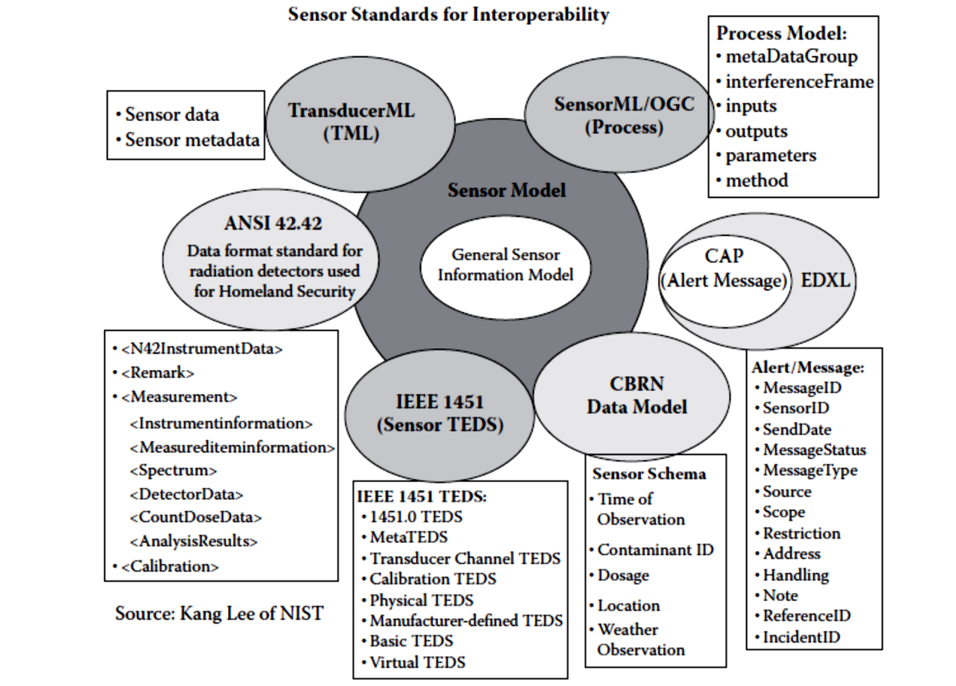

In summary, unified data standards are a foundational element of IoT infrastructure. They promote interoperability, simplify integration, enhance data quality, and support the growth of IoT ecosystems while addressing various challenges related to data management and communication in the IoT landscape.

**Questions:**

1. Knowledge Level (Remember): What is the primary role of unified data standards in the context of the Internet of Things (IoT)?
2. Comprehension Level (Understand): Explain how unified data standards contribute to the efficient exchange of data among diverse IoT devices and platforms. Provide an example to illustrate this concept.
3. Application Level (Apply): Suppose you are developing an IoT solution that involves sensors from different manufacturers. How would adhering to unified data standards simplify the integration of these sensors into your solution?
4. Analysis Level (Analyze): Analyze the impact of unified data standards on the scalability of IoT deployments. How do these standards support the seamless addition of new devices as the IoT ecosystem expands?
5. Synthesis Level (Create): Design a scenario in which unified data standards for IoT play a critical role in ensuring data security and compliance with regulatory requirements. Describe how these standards address security and regulatory concerns in your scenario.

**Answer 1:**

The primary role of unified data standards in the context of the Internet of Things (IoT) is to establish a common framework for data communication, interoperability, consistency, and security across diverse IoT devices and systems. These standards facilitate seamless data exchange, reduce complexity, ensure data consistency, support scalability, and enable compliance with regulatory requirements in the IoT ecosystem.

**Answer 5:**

**Scenario: Smart City Infrastructure**

In the scenario of a smart city infrastructure, where various Internet of Things (IoT) devices are deployed throughout the city to enhance efficiency, security, and quality of life, unified data standards for IoT play a critical role in ensuring data security and compliance with regulatory requirements.

**Data Security Concerns:**

One of the main concerns in this scenario is the security of the data collected and transmitted by IoT devices. Without unified data standards, different devices may use different protocols, encryption methods, or authentication mechanisms, making it difficult to establish a consistent and robust security framework. However, with unified data standards, security measures can be standardized and implemented consistently across all IoT devices, ensuring the confidentiality, integrity, and availability of the data.

Unified data standards can address security concerns in the following ways:

* Standardized Encryption: Unified data standards can specify encryption algorithms and protocols that ensure the data transmitted between IoT devices and the central infrastructure is encrypted and protected from unauthorized access.
* Authentication and Authorization: Standards can define authentication and authorization mechanisms, such as digital certificates or secure tokens, to verify the identity of IoT devices and ensure that only authorized devices can access and transmit data.
* Secure Data Transfer: The standards can outline secure protocols and methodologies for data transfer, ensuring that data is transmitted securely over networks and protected from interception or tampering.
* Secure Storage: Standards can define guidelines for secure storage of IoT data, including encryption at rest, access controls, and secure backup practices, to prevent unauthorized access or data breaches.

**Regulatory Compliance Concerns:**

In a smart city infrastructure, there are likely to be regulatory requirements regarding data privacy, consent, and usage. Unified data standards can help ensure compliance with these regulations by providing a consistent framework for data handling and management. This ensures that the data collected by IoT devices is used in a lawful and ethical manner, safeguarding the privacy and rights of individuals.

Unified data standards can address regulatory concerns in the following ways:

* Data Privacy and Consent: Standards can establish guidelines for obtaining and managing user consent for data collection and usage. This ensures that individuals are informed about the data being collected, its purpose, and have the ability to provide or withdraw consent as required by regulations like the General Data Protection Regulation (GDPR).
* Data Retention and Deletion: Standards can define rules and timeframes for data retention, specifying how long data can be stored and when it should be deleted. This helps organizations comply with regulations that require data to be retained only for specific periods and disposed of appropriately.
* Data Anonymization: Standards can provide guidelines for anonymizing sensitive data collected by IoT devices to protect the privacy of individuals. This enables organizations to use and share data for various purposes while preventing the direct identification of individuals.
* Data Governance and Accountability: Standards can outline governance frameworks that ensure accountability and transparency in data handling. This includes establishing responsibilities for data controllers and processors, implementing audit trails, and enforcing data protection policies and procedures.

By implementing unified data standards for IoT in the smart city infrastructure scenario, organizations can address security concerns by establishing consistent security measures across devices, and ensure compliance with regulatory requirements by defining guidelines for data privacy, consent, retention, anonymization, and governance. This promotes a secure and trustworthy environment for IoT deployments within the smart city, benefiting both the residents and the organizations involved.

**Scenario: Smart Healthcare Monitoring System**

In the context of a Smart Healthcare Monitoring System, unified data standards for IoT play a critical role in ensuring data security and compliance with regulatory requirements. This scenario involves the monitoring of patients' vital signs and health conditions within a healthcare facility or remotely.

**Scenario Components:**

* IoT Devices: These include wearable health sensors, medical equipment (such as ECG machines and infusion pumps), and environmental sensors for monitoring factors like temperature and air quality.
* Data Transmission: IoT devices continuously collect patient data, including heart rate, blood pressure, temperature, and medication dosage. This data is transmitted to a centralized healthcare data platform.
* Data Processing: The healthcare data platform processes and analyzes the incoming data, detects anomalies, and generates alerts for healthcare professionals in real-time.
* Security and Regulatory Compliance: The system must adhere to stringent data security and privacy regulations, such as the Health Insurance Portability and Accountability Act (HIPAA) in the United States or the General Data Protection Regulation (GDPR) in the European Union.

**Role of Unified Data Standards:**

* Data Encryption: Unified data standards for IoT mandate the use of strong encryption protocols during data transmission. This ensures that patient health data remains confidential and secure during transit.
* Access Control: Standards enforce access control mechanisms, allowing only authorized healthcare professionals to access patient data. Role-based access control ensures that data is accessible only by individuals with the necessary permissions.
* Data Integrity: Unified standards include mechanisms for data integrity checks, preventing tampering or unauthorized alterations of patient records. Hashing and digital signatures are examples of such measures.
* Authentication: To comply with regulatory requirements, the IoT devices, healthcare data platform, and authorized users must authenticate themselves using standardized protocols, such as OAuth or mutual TLS authentication.
* Audit Trails: Standards require the generation of detailed audit trails that record all access and modification activities related to patient data. These audit logs facilitate compliance audits.
* Consent Management: Unified data standards can incorporate consent management frameworks, allowing patients to grant or revoke consent for data sharing, in alignment with regulatory requirements.
* Data Retention Policies: Standards outline data retention and deletion policies, ensuring that patient data is not retained beyond the specified periods required by regulations.

**How Unified Data Standards Address Security and Regulatory Concerns:**

* Confidentiality: By enforcing data encryption, access controls, and secure authentication, unified data standards ensure that patient health data remains confidential and is accessible only to authorized personnel.
* Integrity: Data integrity checks and digital signatures prevent unauthorized data tampering, ensuring the accuracy and reliability of patient records.
* Compliance: Unified data standards incorporate regulatory requirements directly into their specifications. This ensures that the system is designed to comply with relevant data protection regulations.
* Accountability: Detailed audit trails provide accountability by recording who accessed patient data, when, and for what purpose. This supports compliance audits and investigations.
* Transparency: Through consent management frameworks, patients have transparency and control over how their data is used, aligning with privacy regulations.

In this scenario, unified data standards for IoT are pivotal in addressing data security and regulatory concerns within a healthcare environment. They provide the necessary framework to safeguard patient data, maintain compliance with healthcare regulations, and ensure the trust and integrity of the healthcare monitoring system.